6396094930 | SAURAV KUMAR
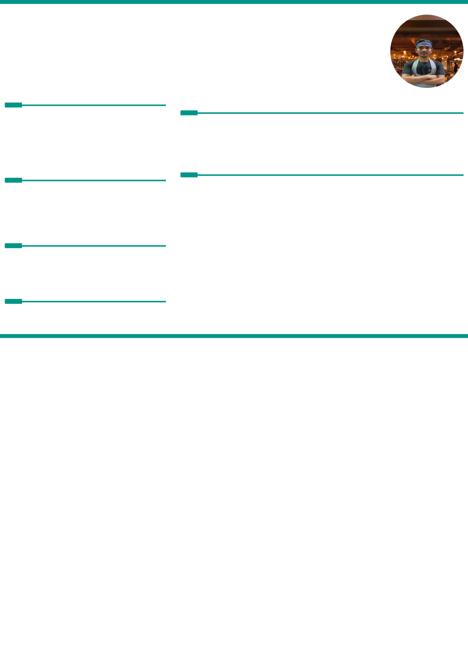

Email I,D:->sauravkm00@gmail.com Uttrakhand ,Dehradun, Poudwala, India, 248001
DOB:->14/05/2000
Mobile No. :-> 6396094930
OBJECTIVE
EXPERIENCE
Highly-motivated employee with desire to take on
new challenges. | Pasta Street ,Bangalore ,India | 13/02/2024 -
Strong work ethic, adaptability and exceptional | Pasta Street ,Bangalore ,India | 14/02/2025
interpersonal skill. Adept at working effectively 1 year experience in Italian cuisine as a Commis 3rd unsupervised and quickly mastering new skills.
EDUCATION
SKILLS
:->Basic Computer | 12th From... N.I.O.S... 2022 | Passing Year -
:->Determined Diploma in Hotel Management from Dev Rishi Educational Society :->Good Orator
:->Excellence in Communication
PERSONAL INFORMATION
Father's Name :-> Pramod kumar
Mother's Name:-> Pushpa devi
Martial status:-> Unmarried
LANGUAGE
:->Hindi
:->English

