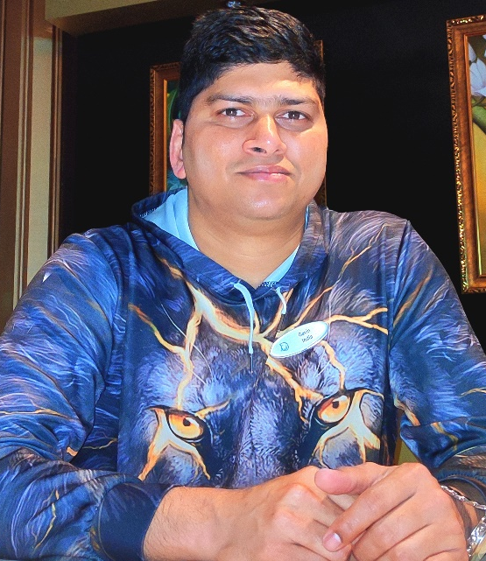

GAVIN ALMEIDA
gavin.gap@gmail.com
+91 9823144310
+91 9823622420

Personal Information

Date of Birth: 12 December 1980
Address: H No 11/A, Cana Benaulim,
Salcete - Goa
Nationality: Indian
Place of Birth: Margao Goa
Height: 178cm
Weight: 90 kgs

Education:
- Successfully completed Graduation in Arts from Rosary College of Commerce and Arts from June 2000 till April 2003.
- Completed Higher Secondary in 2000 with 60% from St. Xavier’s Higher Secondary School. India.
- Completed a 3 months course in Food & Beverage from Fr. Agnel Institute Margao. India.

Additional Completed Courses:
STCW ,Crowd Management, Crises Management, Basic Soft skills, Developing Supervisory Skills and Train The Trainer.
Passport –Indian Passport, Expiry Date –July 2027
CDC –Indian CDC/Bahamas CDC

Objective
To promote and ensure guest satisfaction, maintain a safe working environment, and ensure the highest quality service to the clients. Gather constructive feedback from guests to ensure satisfaction of every individual guest. Handle daily team member relations, and encourage problem solving by team

members through proper training and empowerment.

Skills
Almost 15 years of experience in the hotel industry and cruise Industry. Enjoyed working with multi- functional qualities and various nationalities in order to achieve the goal and target set by the organization

.

Work Experience
Food and Beverage Supervisor (M/V Explorer Dream & M/V Resorts World Cruises)
April 2023 – February 2025
Job Description:
    - Always aware of the importance of sales volume and cease to make sure every effort is made, both by themselves and by those they supervise to continue to upsell while not compromising on guest satisfaction.
    - Supervising the work of all crew in the outlet and evaluate job performance and makes recommendations to the manager.
    - Assisting in making sure all standard service procedures are adhered to and carried out as per the company standards.
    - Providing constant on the job trainings, maintaining personal cleanliness and good grooming ensuring that all crew are punctual and well-groomed with proper uniform.
    - Ensuring proper company standards of service procedures are followed by all the restaurant crew.
    - Assist the manager in preparing the station plan and outlet setup for any upcoming functions or events on board.
    - Assigning crew with various duties and responsibilities to maximize sufficiency and productivity.
    - Check the appearance, orderliness, cleanliness and proper setup of the outlet and surrounding areas.
    - Conveying any guest criticism and complaints on the quality of products or service to the manager as well as service compliments.
    - Handling the outlet operations in absence of the outlet manager.
    - Handling and preparing the daily outlet report on the F&B sales volume on a daily basis as well as weekly basis.
    - Inform guests and crew on all the guests facilities on board including facilities in other departments and update as soon as possible if there are any changes in the facilities.
    - Conduct briefings to the crew on the day’s highlights, Outlet budget, ongoing crew trainings and drills and monitoring all aspects of outlet operations.
    - Fully versed in safety procedures on board.

Service Captain (Dream Cruises M/V GDR & M/V Explorer Dream)
January 2018 – April 2023.
Job Description:
    - Maintain a professional appearance, hygiene and uniform at all times.
    - Is punctual, efficient and courteous. Have a helpful attitude towards guests at all times.
    - Attend to the arrival of guests and greet them pleasantly even if they cannot be accommodated immediately.
    - Relay customer complaints to the supervisor consistently at a soonest possible time. Report feedback for follow-up actions.
    - Aware of the duty roster and give adequate notice whenever serious circumstances prevents adherence to the roster.
    - Familiar with all facilities/services and updated on important information about the Food and Beverage operations and hotel in general to provide accurate answers to queries.
    - Display a positive attitude during work and set a good example for crew to follow.
    - Aware of the policies and procedures and ensures these are implemented and adhered to at all times.
    - Courteous and helpful at all times. Ensure that guest requests are relayed to subordinates properly or should act on these if the staffers are occupied.
    - Communicate information from the management to the crew and vice versa.
    - To follow standards and procedures as set for all shifts and to complete all assignments given.

Communication

- Attend weekly Food and Beverage meeting and service meetings (when applicable).
- Conduct briefings to ensure that information is disseminated
- Maintain a logbook for administrative references and crew communication.
- Post all current information and standing instructions on the notice board.
- Write down all items not available or seasonable on the board for crew’s references.
- Communicate and present a positive attitude to provide leadership to crew at all times to attain desired results.

Standard of Performance

- Job Section

- Check proper staffing of the outlet.
- Ensure adequate supplies of operational equipment’s.
- Checks outlet for cleanliness and hygiene.
- Conduct briefing, check uniform and grooming of the crew.
- Greet guest (wherever possible).
- Maintain a professional relationship with other departments to avoid friction.
- Ensure a consistency of standard for maximum guest satisfaction in their outlet.
- Communicate with all crew members about guest feedback on the quality of products and services.
- Properly delegates responsibilities to the crew, according to their discretion and with proper instructions.
- Maintain and review service manuals.
- Conduct training sessions consistently.
- Maintain a checklist for daily inspections.
- Conduct periodical crew meetings and encourages two-way communication.

Waiter (Star Cruises M/V Superstar Gemini)
November 2015- December 2017.
Job Description:

- Handle complaints and requests in a prompt manner and ensures that guests are satisfied with the service before they leave the outlet.
- Maintain a good appearance and create a lasting impression.
- Attends training when required to enhance product knowledge.
- Ensure general cleanliness and hygiene practices in workplace and accommodation.
- Perform duties efficiently and to the best of ability.
- Provide services to the highest standard to experience excellent dining.
- Smile and greet guest warmly with eye contact.
- Is attentive while guest is in the outlet and provide prompt service.
- Anticipate guest needs and act promptly on their requests and suggestions.
- Seek assistance from your superiors if can’t handle guest requests, queries or complaints.
- Inform his/her superior pertaining to guest’s comments or complaints immediately.
- Knowledgeable about onboard products, facilities and promotion especially of Food and Beverage Section.
- Is required to assist in other outlets when necessary.
- Ensure that bills of designated tables are opened and settled in a prompt and accurate manner.
- Avoid serving alcohol to minors, request for identification from anyone who appears underage (in accordance with company Policies and Procedures).
- Answer telephone calls in an appropriate manner.
- Knowledgeable and skillful about the outlets service procedures including food and beverage.

Front Office Supervisor (Royal Orchid Beach Resort & Spa – Goa . India)
October 2007- June 2015.
Job Description

- To overview and ensure the smooth operation of all the activities of the front office.
- To monitor and review the checklist of all the arrival and departures.
- To give a warm welcome to all the guests especially the VIP's and to provide them with the best possible services.
- To handle the booking and reservation duties and to resolve issues if there are any complaints, especially about the quality of services delivered by the staff members.
- To work as per the instructions given by the front office manager and to organize and coordinate all the front office duties.
- To supervise the front office staff and to ensure that they adhere by the rules and regulations of the hotel and to make sure that discipline is followed by all the staff members.
- Responsible for communicating and directing the staff members in a clear and concise manner and provides details regarding their work if possible in a written format.
- Listens carefully to the requests made by the incoming guests and tries to understand and respond to them by giving appropriate details regarding the timings of the outlets, near by tourist spots, local attractions, etc.
- Involved in the registration process and retrieving data whenever there is a need.
- Verifies the credit cards for authorization and handles all cash and posts charges.

References:
- Name : Mr. Tokutaro Yamauchi
Designation : Hotel Director
Email: gwmdf053@yahoo.co.jp
Contact Number : +63 9218725039

- Name : Mr. Arnold Deala
Designation : Food & Beverage Manager
Email: arnold_deala1074@yahoo.com
Contact Number: +639206450299

