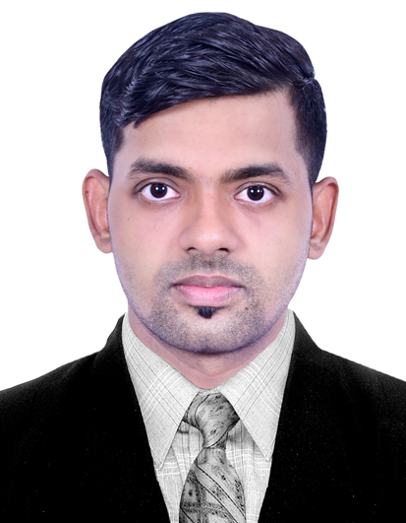
KRISHNA KUMAR
Address : s/o Rajesh yadav plot no. 24 pragati nagar
gandhiwadi umbergaom,valasad,gujarat, India 396170.
Email ID : kreshyadav54321@gmail.com
Personal Details :
Date of birth : 24- 11-1998 sex : male
Place of birth : Ayodhya utter pradesh Nationality : indian
Mobile No. : 9687007622 country : india
Career objective :
To pursue a challenge and rewardig career in the hotel and hospitality industry as a senior captain where i could build our knowledge and experience being an outstanding performer by constant learning with disciplind,hard work confidence and dedication towards responsibilities.

Work Experience :
Company | Duration | Designation | Location
Peninsula Redpine | 2 year | Trainee steward | Airport Road andheri
T24 Residency | 6 month | Steward | Marol Naka andheri
Peninsula Redpine | 6 month | Senior Steward | Marol Naka andheri
Fortune park galaxy (Sam's alive again ) | 1year 9month | Captain | Hotel Fortune Park, Galaxy HighStreet, Fortune Hotel, Vapi.
Daman Ganga valley Resort | currently working | Sr. Captain | Silvassa

Educational Qualification :

Examinatin passed | Institution | Board | Percentage | Year
Hotel management (B.Sc) | Rustomjee Academy for global careers | Ycmou | 65.9% | 2019
H.S.C. | Shri Madhusudan MS College | U.P. | 69.5% | 2016
S.S.C | Chandrashekhar Azad Inter College | U.P. | 67.5% | 2014

Area of interest :
- Food and beverage department.
Job Responsibilities :
- Coordination and co-operating with other departments.
- Carried out multi skilled operations in the department.
- Maintain per stock & inventory.
- Leading a team of as per desired direction of establishment with high motivation.
- Maintain of food & beverage service standard.
- Communicate with our team to check the par stock requirement in operation.
- Induction and training of new employees.
- Take briefing and explain to all information about guest and food & service standard.
- Marinating all file work related to food & beverage service.
- Maintain of cleanliness and sanitation for station hygiene of the restaurant.
Skills :
Language known : Hindi, English, Marathi.
Computer: 1 Year advance computer course (ADCA).
Hobbies: cricket, travelling , cooking food.
Decleration .
I hereby declare that all the information given above are true and verified with the best of my knowledge.

Place :
Date: signature

