
CURRICULUM VITAE

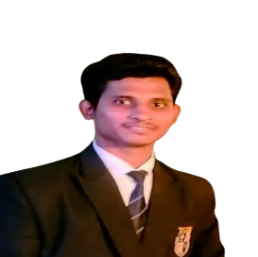  Name : Dhiraj N. Bambole  Permanent Address Ambedkar Chowk, Malewada, Tal Chimur, Dist Chandrapur Maharashtra 442903  Contact Details:  +91- 7620847586  E-mail:  dhirajbambole26@gmail.com  Personal Data:  Father’s Name: Nilkanth Bambole Date of Birth : 01/12/2002 Gender : Male  Nationality : Indian Height : 5.6 ft Marital Status: Single  Hobbies: Cooking , Playing Cricket, Playing Kabaddi, Reading Newspaper  Languages Know: English, Hindi and Marathi | Objective:
 | To Work In An Environment Which Encourages Me To Succeed And Grow Professionally Where I Can Utilize My Skills And Knowledge Appropriately.
 | Education
- Pursuing 4th Year Bachelor Of Hotel Management And Catering Technology From Tuli College Of Hotel Management.
- HSC Passed From Maharashtra State Board - Neharu Junior College, Chimur With First Division
- SSC Passed From Maharashtra State Board - Neharu Vidhyalaya Chimur. With Second Division
 | Extra-Curricular Activities
- Got 3rd Rank In District Level Kabaddi Competation In School Level.
- Participated In Science Exhibition In 2018.
- Participated In Food Fare In 2020
- Completed Industrial Training At Club Mahindra Emerald Palm, Goa In Year 2022
- Completed Industrial Training At The Corinthians Resort And Club Pune In Year 2024

 | Computer Skill
 | - Basic Knowledge of Computer.
 | Interested department: Food Production
I Hereby Declare That Above Information Provided By Me Is True And Complete To The Best Of Knowledge.

Date:- 07/01/25
Place : - Nagpur

