
RESUME
POST APPLIED FOR : SECURITY GUARD
NAME : MEESALA LOKESH
FATHER NAME : NAGARAJUMEESALA
DATE OF BIRTH : 01/09/1977
NATIONALITY : INDIAN
MARTIALSTATUS : MARRIED
NEXT OF KIN : MEESALA PRAVEETHA
EDUCATIONAL QUALIFICATION : INTER, DIP IN SAFETY, NEBOSH (IGC), OSHA
LANGUAGE KNOW : ENGLISH/HINDI/TELUGU
PRESENTADDRESS | PERMANENTADDRESS
20-47-5,DOWNRELLISTREETNEARRAMNADH | 20-47-
HOTELAVNCOLLEGEROADVISAKHAPATNAM | 5,DOWNRELLISTREETNEARRAMNADHHOTELAVNCOLLEG
URBANPIN :530001ANDHRAPRADESHINDIA | EROADVISAKHAPATNAM
EMAIL ID : meesalalokesh55@gmail.com | URBANPIN :530001ANDHRAPRADESHINDIA
CONTACT : +918919949606 | CONTACT : +91707576618
 | EMAIL : meesalalokesh55@gmail.com
PERSONALDOCUMENTS:
DOCUMENT | NUMBER | ISSUEDATE | VALIDITY | ISSUEAT
PASSPORT | V4500136 | 02/12/2021 | 01/12/2031 | VISAKHAPATNAM
INDIANCDC | KOL 101153 | 22/09/2023 | 21/09/2033 | KOLKATA
INDOS | 13HL1182 | 26/07/2013 | LIFE TIME | MUMBAI
YELLOWFEVER | LOT NO 424 | 19/06/2014 | 18/06/2024 | MUMBAI
SID | C33439574 | 12/05/2023 | 11/05/2033 | CHENNAI

S.T.C.W.COURSES:
COURSESNAME | CERTIFICATENO | ISSUEDATE | ISSUEDAT
EFA | 41403861012300515 | 14/02/2023 | VIZIANAGARAM
FPFF | 41403861012300515 | 14/02/2023 | VIZIANAGARAM
PSSR | 41403861012300515 | 14/02/2023 | VIZIANAGARAM
PST | 41403861012300515 | 14/02/2023 | VIZIANAGARAM
STSDSD | 41403866212300315 | 10/02/2023 | VIZIANAGARAM
OCTCO | 20301051112315510 | 11/12/2023 | MUMBAI
OCTCO (DC) | COPDGSOAC23119674 | 13/12/2023 | MUMBAI

ABROAD EXPERIENCE:
COMPANY NAME | RANK | FROM | TO
NASSERS S ALI HAJRI CORPORATION ( KUWAIT ) | SECURITY GUARD | 19/02/2016 | 06/10/2020
SAMBO ENGINEERING COMPANY (ABU DHABI) | SECURITY GUARD | 20/11/2011 | 02/02/2013
TARGET ENGINEERING COMPANY (ABU DHABI) | SECURITY GUARD | 02/07/2009 | 15/09/2011
C C C W.L.L. (KUWAIT) | SECURITY GUARD | 09/02/2008 | 26/07/2008
PETRON EMIRATES W.L.L. (DUBAI) | SECURITY GUARD | 30/09/2006 | 26/06/2007
I S C O W.L.C. (KUWAIT) | SECURITY GUARD | 30/02/2006 | 04/04/2006
MEESALA LOKESH
PLACE: VISAKHAPATNAM

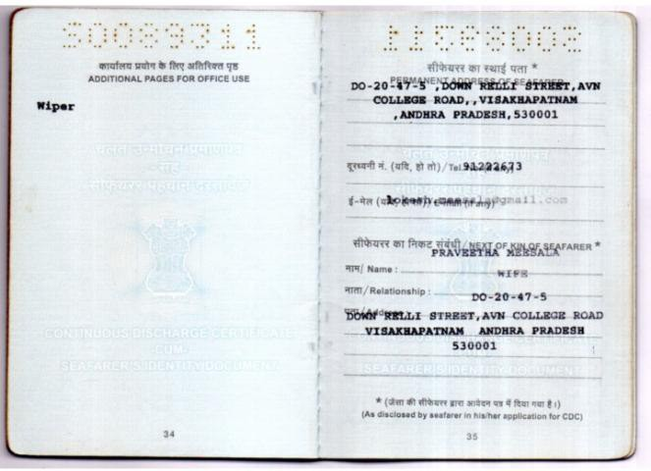

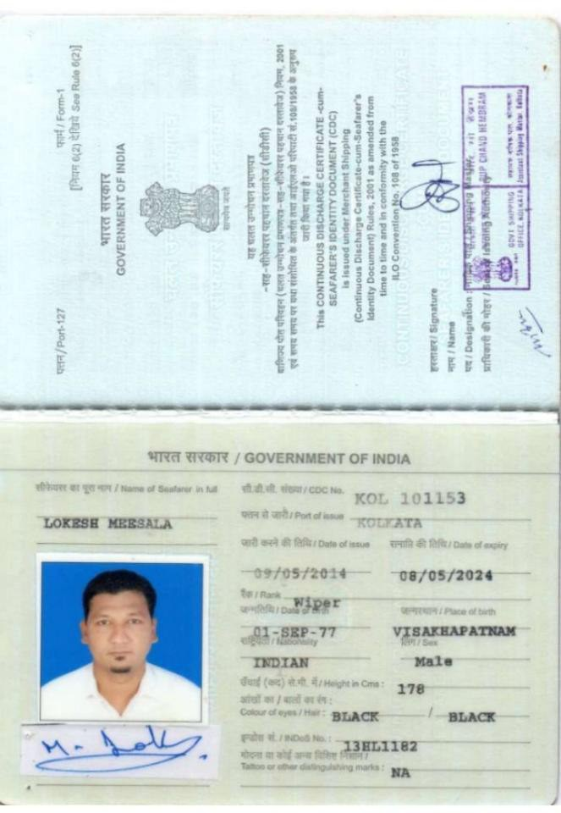

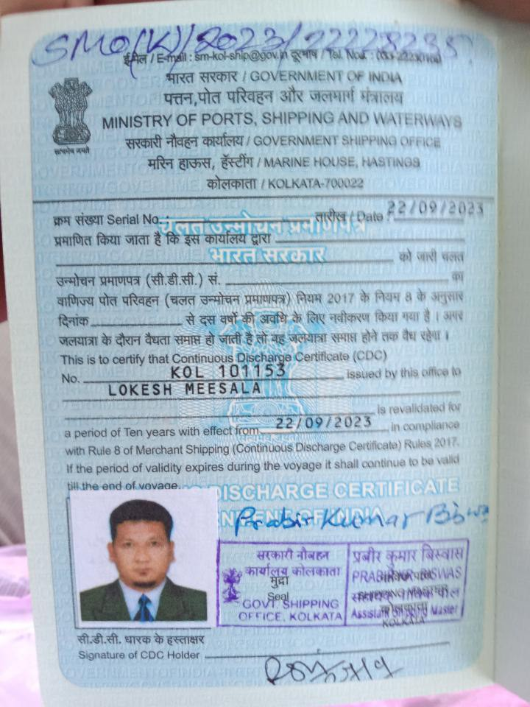

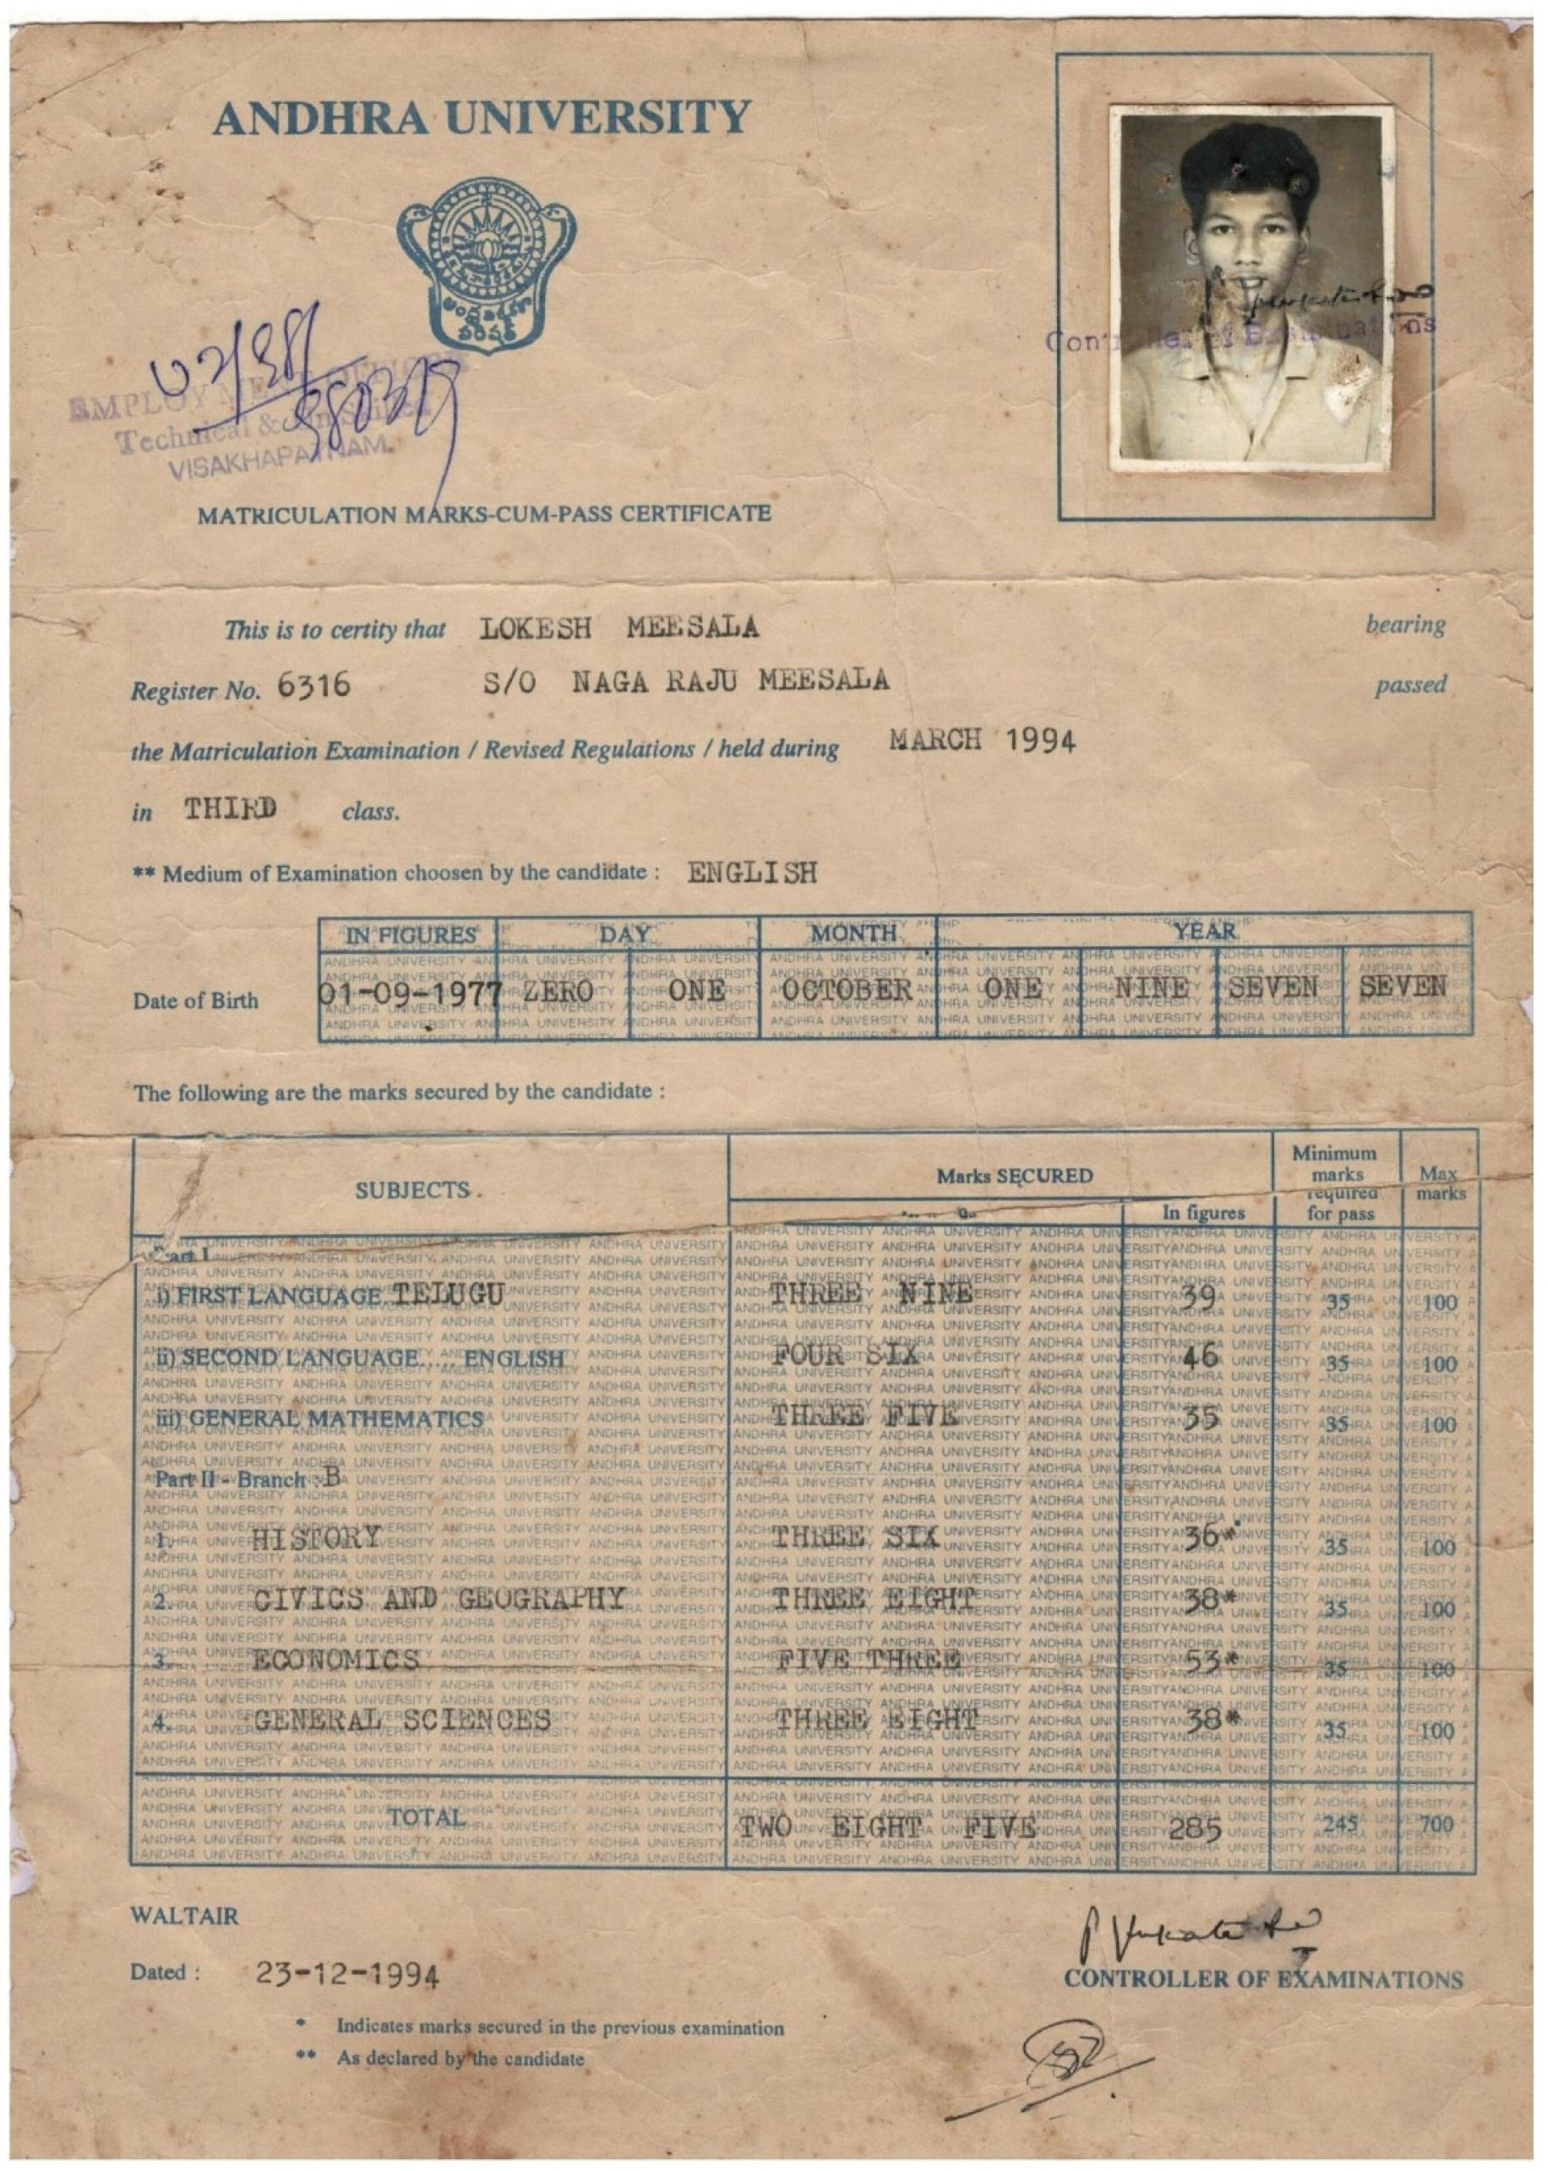

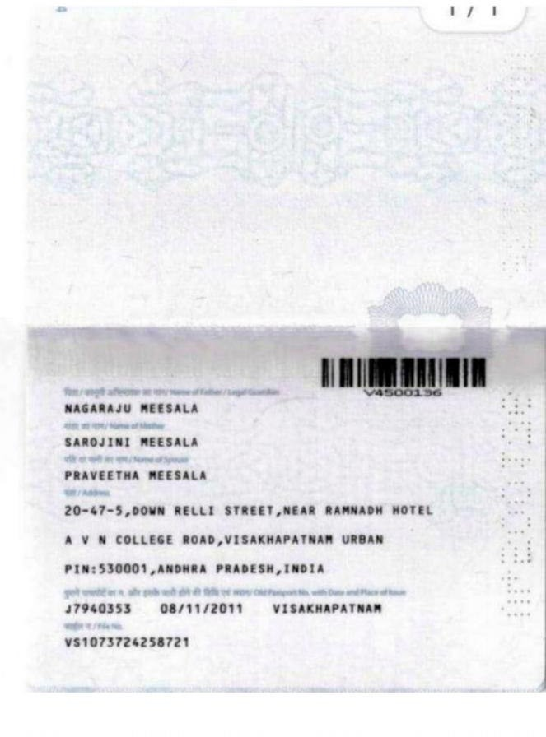

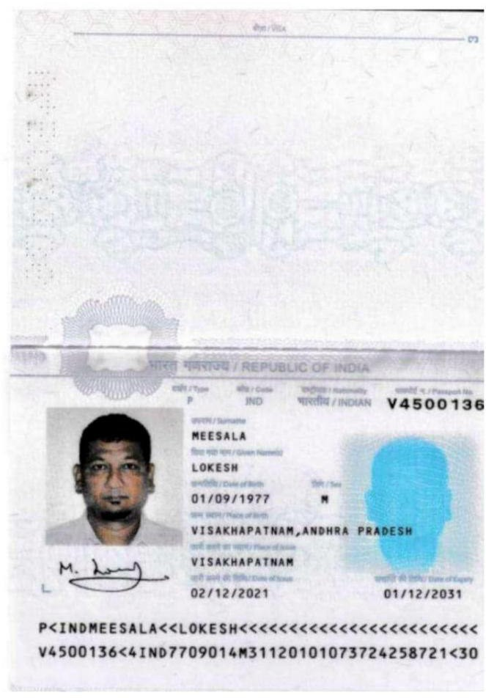

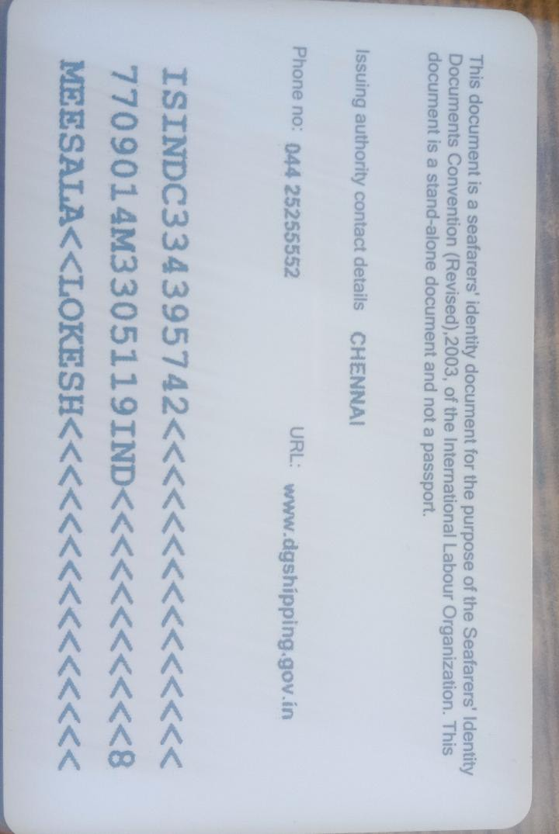

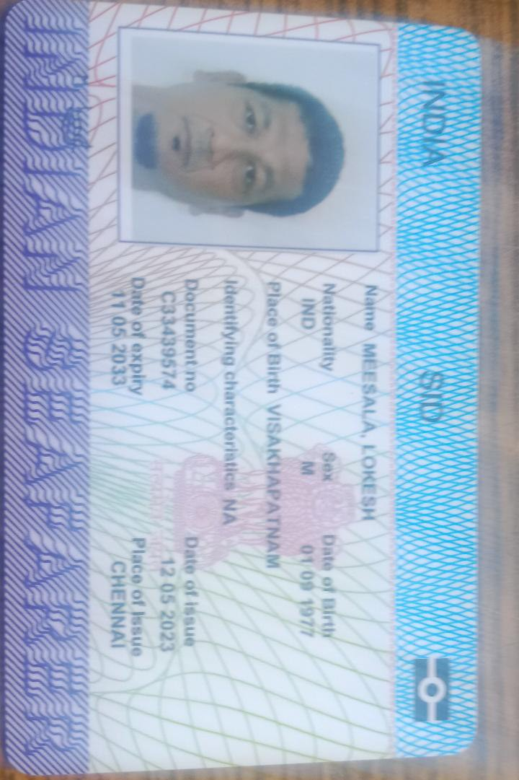

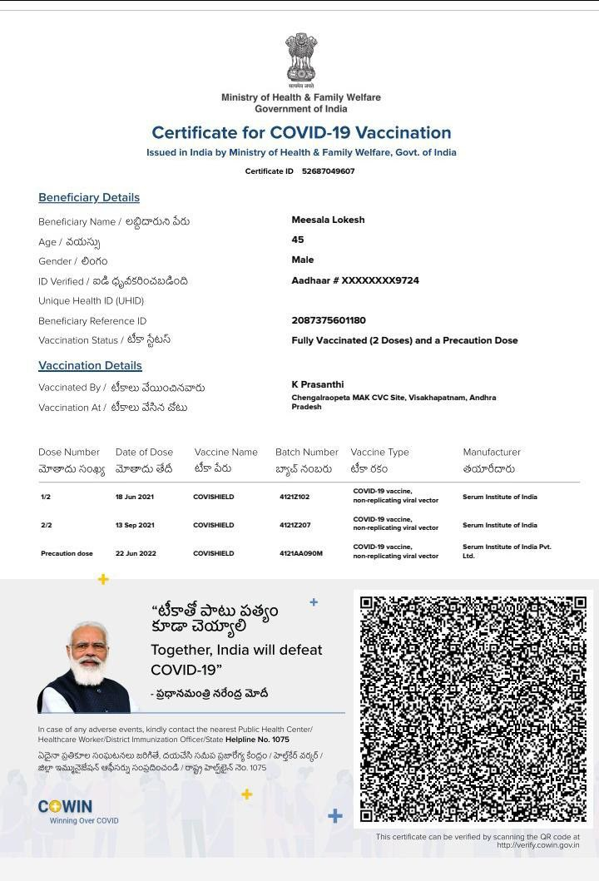


Certificate No. 41403866212300315

Behara Institute of Maritime Training

KOTYADA VILLAGE, L. KOTA MANDAL,, VIZIANAGARAM, ANDHRA PRADESH

City : VIZIANAGARAM
District
: VIZIANAGARAM
State
: Andhra Pradesh
Pin
: 535240

MTI No. : 414038
Tel
: 08912793745
Fax
: 08912718659
E-mail : beharamaritime@gmail.com

THIS IS TO CERTIFY THAT Messala Lokesh

Date of Birth 01/09/1977 (dd/mm/yyyy)

Indian National Database of Seafarers (INDoS No.) 13HL1182

has successfully completed a training course held from
20/01/2023
to 21/01/2023
for :

Certificate of Proficiency in Security Training for Seafarers with Designated Security Duties

The course is approved by the Directorate General of Shipping and meets the requirements laid down in Regulations VI/6 paragraph 4 to 6, Section A-VI/6 Paragraph 6 to 8 and Table A-VI/6-2 of the STCW Convention, 1978, as amended. The candidate has also met the additional criteria specified in the STCW Convention, applicable to the issue of the certificate.

This certificate is issued under the authority of the Directorate General of Shipping, Ministry of Ports, Shipping and Waterways, Government of India.

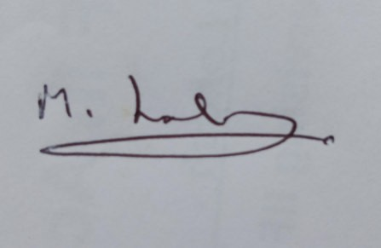Date of Issue :
10/02/2023
Date of Expiry : NA

Signature of Candidate
Digitally signed by VADAMODULA HARIPRASAD
Date: 2023.02.15 11:31:41 +05:30

Name and Signature of Course In-charge Capt. Hari Prasad Vadamodula


Digitally signed by NARASINGA RAO PEDADA
Date: 2023.02.15 11:54:25 +05:30
Name and Signature of Dean / Principal Narasinga Rao Pedada

DGShippingDigital / version 1.3 / 14-June-2021

Certificate No. 41403861012300515

Behara Institute of Maritime Training

KOTYADA VILLAGE, L. KOTA MANDAL,, VIZIANAGARAM, ANDHRA PRADESH

City : VIZIANAGARAM
District
: VIZIANAGARAM
State
: Andhra Pradesh
Pin
: 535240

MTI No. : 414038
Tel
: 08912793745
Fax
: 08912718659
E-mail : beharamaritime@gmail.com

THIS IS TO CERTIFY THAT Messala Lokesh

Date of Birth 01/09/1977 (dd/mm/yyyy)

Indian National Database of Seafarers (INDoS No.) 13HL1182

has successfully completed a training course held from
23/01/2023
to 07/02/2023
for :

Certificate of Proficiency in Personal Survival Techniques, Fire Prevention & Fire Fighting, Elementary First Aid and Personal Safety and Social Responsibilities

The Course is approved by the Directorate General of Shipping and meets the requirements laid down in Regulation A- VI/1, Section A-VI/1 Para 2.1, Table A-VI/1-1, Table A-VI/1-2, Table A-VI/1-3 & Table A-VI/1-4 of the STCW Convention,1978, as amended.

This certificate is issued under the authority of the Directorate General of Shipping, Ministry of Ports, Shipping and Waterways, Government of India.

Date of Issue :
14/02/2023
Date of Expiry : NA

Signature of Candidate
Digitally signed by VADAMODULA HARIPRASAD
Date: 2023.02.16 12:00:14 +05:30

Name and Signature of Course In-charge Capt. Hari Prasad Vadamodula

Digitally signed by NARASINGA RAO PEDADA
Date: 2023.02.16 12:25:00 +05:30
Name and Signature of Dean / Principal Narasinga Rao Pedada

DGShippingDigital / version 1.2 / 14-June-2021

GOVERNMENT OF INDIA CERTIFICATE OF PROFICIENCY IN
BASIC TRAINING FOR OIL AND CHEMICAL TANKER CARGO OPERATIONS
( Regulation V/1-1 Paragraph 2 of STCW Convention, as amended )
CERTIFICATE ISSUED UNDER THE PROVISIONS OF THE MERCHANT SHIPPING ACT, 1958 (44 OF 1958), AS AMENDED, AND THE INTERNATIONAL CONVENTION ON STANDARDS OF TRAINING CERTIFICATION AND WATCHKEEPING FOR SEAFARERS (STCW), 1978, AS AMENDED.

The Government of India certifies that LOKESH MEESALA has been found duly qualified in accordance with the provisions of Regulation V/1-1 Paragraph 2 of STCW Convention, as amended, and has been found competent to perform the following functions at the levels specified, subject to any limitations indicated:

Type of Tanker | LEVEL OF TRAINING | LIMITATION APPLYING (IF ANY)
Oil and Chemical | BASIC TRAINING | NONE

Certificate No. :

COPDGSOAC23119674
Issue Date :

13-DEC-2023

Date of Expiry :

5-Years from date of issue for "Master and Officers" and Un-Limited for Ratings.

The original of this certificate must be kept available in accordance with Regulation I/2 Paragraph 11 of the STCW Convention, as amended, while its holder is serving on a ship.

Date and Place of birth of holder of the certificate 01-SEP-1977 / VISAKHAPATNAM ANDHRA PRADESH

Signature of the holder of the certificate

INDoS No. :

13HL1182
Seafarer's Identification Document No. :

COPDGSOAC23119674
CDC No. :
KOL 101153

Photograph of the holder of the certificate
Digitally signed by DS DIRECTORATE GENERAL OF SHIPPING 1
Issue Date: 13-DEC-2023 Reason: Certificate Authorisation Location: MAHARASHTRA, IN

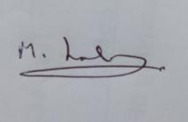
Signature of duly authorised Officer

Praveen Nair

Engineer & Ship Surveyor-cum-DDG (Tech)

Issued by : Directorate General of Shipping
Government of India

Contact details : Directorate General of Shipping, 9th floor, BETA Building, I-Think Techno Campus, Kanjur Marg (East), Mumbai - 400042, INDIA. Phone: 91-22-25752040/41/42/43/45, Fax: 91-22-25752029/35, E-mail: dgship-dgs@nic.in.
The authenticity of this certificate can be verified online using INDoS/COP Checker on website www.dgshipping.gov.in.

Certificate No. 20301051112315510

Asha International Institute of Marine Technology

CITY TOWER, C WING , 3RD FLOOR , PLOT NO 55 , SECTOR 15, CBD BELAPUR,NAVI MUMBAI

City : NAVI MUMBAI
District
: THANE
State
: Maharashtra
Pin
: 400614

MTI No. : 203010
Tel
: 02241271093
Fax
: 02241312666
E-mail : AIIMTMUMBAI@AIIMTVNS.COM

THIS IS TO CERTIFY THAT Meesala Lokesh

Date of Birth 01/09/1977 (dd/mm/yyyy)

Indian National Database of Seafarers (INDoS No.) 13HL1182

has successfully completed a training course held from
04/12/2023
to 09/12/2023
for :

Basic Training in Oil and Chemical Tanker Cargo Operations

The course is approved by the Directorate General of Shipping and meets the requirements laid down in Regulation V/1-1 of the STCW Convention, 1978, as amended and the mandatory minimum standards of competence given in Table A-V/1- 1-1 of the STCW Code.

The candidate has also met the additional criteria specified in the STCW Convention, applicable to the issue of the certificate. This certificate is issued under the authority of the Directorate General of Shipping, Ministry of Ports, Shipping and Waterways, Government of India.

Date of Issue :
11/12/2023
Date of Expiry : NA

Signature of Candidate
Digitally signed by VIKRAM CHANDRAKANT MHATRE
Date: 2023.12.12 13:18:41 +05:30

Name and Signature of Course In-charge Mr. Vikram Chandrakant Mhatre



Digitally signed by Vernon Terence Godin
Date: 2023.12.12 15:10:32 +05:30
Name and Signature of Dean / Principal Mr Vernon Godin

DGShippingDigital / version 1.3 / 14-June-2021

