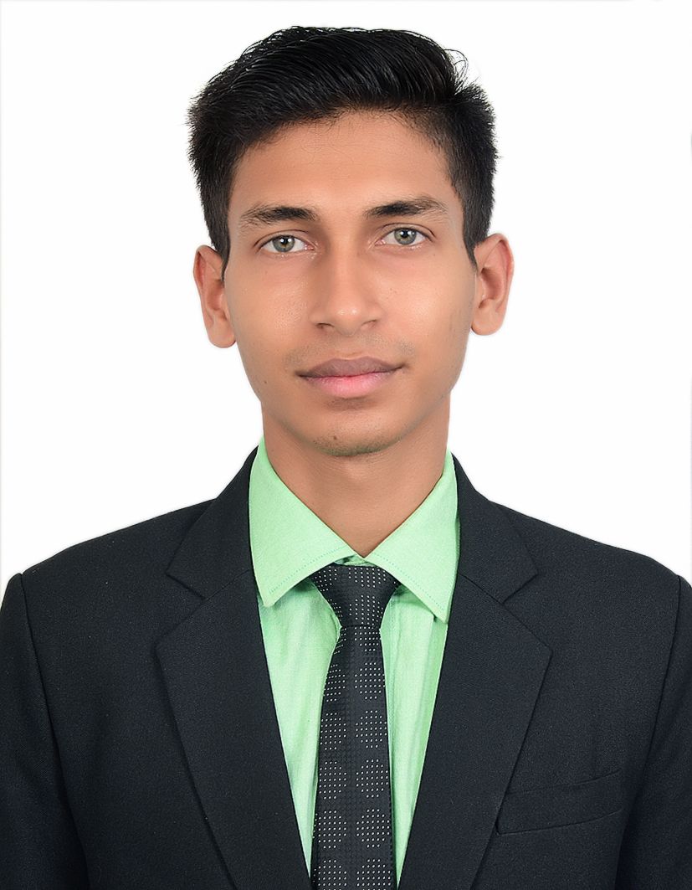
MOJAHIDUL ISLAM MOLLICK
Email ID :- mojahidulislammollick@gmail.com
Mobile No :- +91 7980027575
Current Location :-Ahmedabad , India

OBJECTIVE
To work in a challenging environment demanding all my skills and adapt myself in different fields for the development of the organization with impressive performance.

WORK EXPERIENCE

The Lounge (Lite Bite Travel Food Pvt Ltd) April 2023 – Present
Ahmedabad International Airport Terminal 1, Gujarat, India
- As a Senior Captain
The Lounge (Lite Bite Travel Food Pvt Ltd) April 2022 - April 2023
Ahmedabad International Airport Terminal 1, Gujarat, India
- As a Captain
Pasta Street India Pvt Ltd September 2021 - January 2022
Bengaluru, Karnataka, India
- As a Senior Steward
Lumee Street Cafe (Al Abraaj Group Of Restaurants) March 2019 - March2020
Saar , Kingdom Of Bahrain
- As a Waiter cum Cashier
Pasta Street India Pvt Ltd March 2018 - March 2019
Bengaluru, Karnataka, India
- As a Steward
City Tea Junction Pvt Ltd July 2017 - December 2017
Kolkata, West Bengal ,India
- As a team members

JOB RESPONSIBILITIES
- Greets guests. Presents menus and inform of any specials.
- Makes recommendations and answers questions regarding food and beverage.
- Provides excellent service to ensure customer satisfaction.
- Takes food and beverage orders. Does suggestive selling and serves orders efficiently.
- Prepares hot and cold beverages.
- Handling guest complaints.
- Cleans and sets up dining areas, refills condiments, rolls silverware into napkin and stock service area.
- Ensures the dining and bar areas are always clean and tidy.
- Delivers exceptional, friendly and fast service.
- Answers questions about menu selections and makes recommendations.
- Records orders and addresses guest service needs.
- Appropriately suggests additional items to customers to increase restaurant sales.
- Accurate cash handling procedure.
- Presents bill and processes cash, credit or debit payments.
- To manage the team as a professional , ensuring efficient and flexible service.
- Effectively communicates with kitchen staff regarding customer allergies, dietary needs, and other special requests.
- Regularly checks on guests to ensure satisfaction.
- Routinely cleans table linens, table settings, glassware, glass panels , counters, floors and service refrigerators.
- Making weekly inventory maintenance report, opening, closing and cash closing and sell report.

EDUCATIONAL ATTAINMENT

Tertiary Frankfinn Institute of Air Hostess Training
Kolkata, West Bengal, India
Diploma in Hospitality Management
2016-2017

Higher Secondary West Bengal Council of Higher Secondary Education
Kalipur high school, Budge Budge
Kolkata, West Bengal, India
2014 – 2016

Secondary West Bengal Board of Secondary Education
D.P.S.S.S.kumari sikshaniketan, Budge Budge
Kolkata, West Bengal, India
2008 – 2014

SKILLS AND ABILITIES

General Office Application : MS Office Applications (MS Word, MS Excel)
Food and Wine Servicing : Food Service, table skirting, napkin folding
Culinary Skill : Asian and International Cuisine
Bartending Skills : Wine Mixing, Mocktail making, Flair Bartending
Baking Skills : Cake Baking and Decorating

STRENGTHS
- Smart working
- Punctuality
LANGUAGE PROFICIENCY

Read & Write : English, Hindi, Bengali
Speak : English, Hindi, Bengali
PERSONAL DATA

Father : Mohammad Saiyed Ali Mollick
Date of Birth : January 11, 1998
Gender : Male
Marital status : Single
Nationality : Indian
Passport No : P9331866 (April 13, 2017 To April 12, 2027)
Interests : Playing and Watching Football, Cooking , Music, service

REFERENCES Available upon request

I hereby certify the above statements are true and correct to the best of my knowledge and belief.
Date :
Place : MOJAHIDUL ISLAM MOLLICK

