CURRICULUM VITAE

GOURAV SHARMA Add.:- Vill. Karampur, Post- Tapukara, Teh. Tijara, Dist.-Alwar (Raj.) 301707 Contact No:- 9549332659, Email:- gs5901352@gmail.com
Career Objective
- To work in challenging atmosphere in a reputed organization /company where I can prove and utilize my abilities and skill set in order to achieve personal and professional goal.
Professional Qualification
S.NO. | Name of examination | Institute/ College / School | University/ Board | Year of passing
01 | BHMCT (HOTEL Management ) | Nims University Jaipur | Nims University | Complete in May 2014
02 | Sr. Secondary | COL. Ram Chandra Model Sr. Sec. School | Rajasthan Board Ajmer | 2011
03 | Secondary | COL. Ram Chandra Model Sr. Sec. School | Rajasthan Board Ajmer | 2009

Industrial Exposure
- Six months Industrial training in Park Plaza Faridabad (Haryana).2012
Working Experience
- Worked at Savoy Suits Manesar as a Trainee Asst. Steward from 06.Aug.2014 to 25th June 2015.
- Worked at park inn Gurgaon as a steward from 15th sep.2015 to25th sep.2017.
- Worked at country inn suits bhiwadi as a senior steward from 3 oct.2017 to 25 nov.2018.
- . worked at veta hotel in kurukshetra as a caption from 25 April 2019 to 20 March 2020.
- Currently working in DLF Regal garden club in Gurgaon as a senior steward from 19 July 2020 to till now.

Computer Skills
- Basic Knowledge of Computer.

JOB PROFILE :
- Providing excellent meal experience to the guest by maintaining service standard and exceeding guest expectation.
- Core competencies in streamlining entire operations with ability to manage it as a profit Centre. Expert in managing situation, .
- Ensuring proper settlement of bill before posting in room or account.
- Professional strengths in managing inventory of various items to logical levels with deft application of inventory management techniques. Demonstrated abilities in defining layout of restaurant.
- Perfect team work with innate strengths to take up fresh professional challenges at any point
- Self-driven, focused and result oriented with strong analytical and problem solving skills.
- Excellent written and verbal communication abilities.
- Closing the bill & taking out the sale summary.\
- Able to handle a 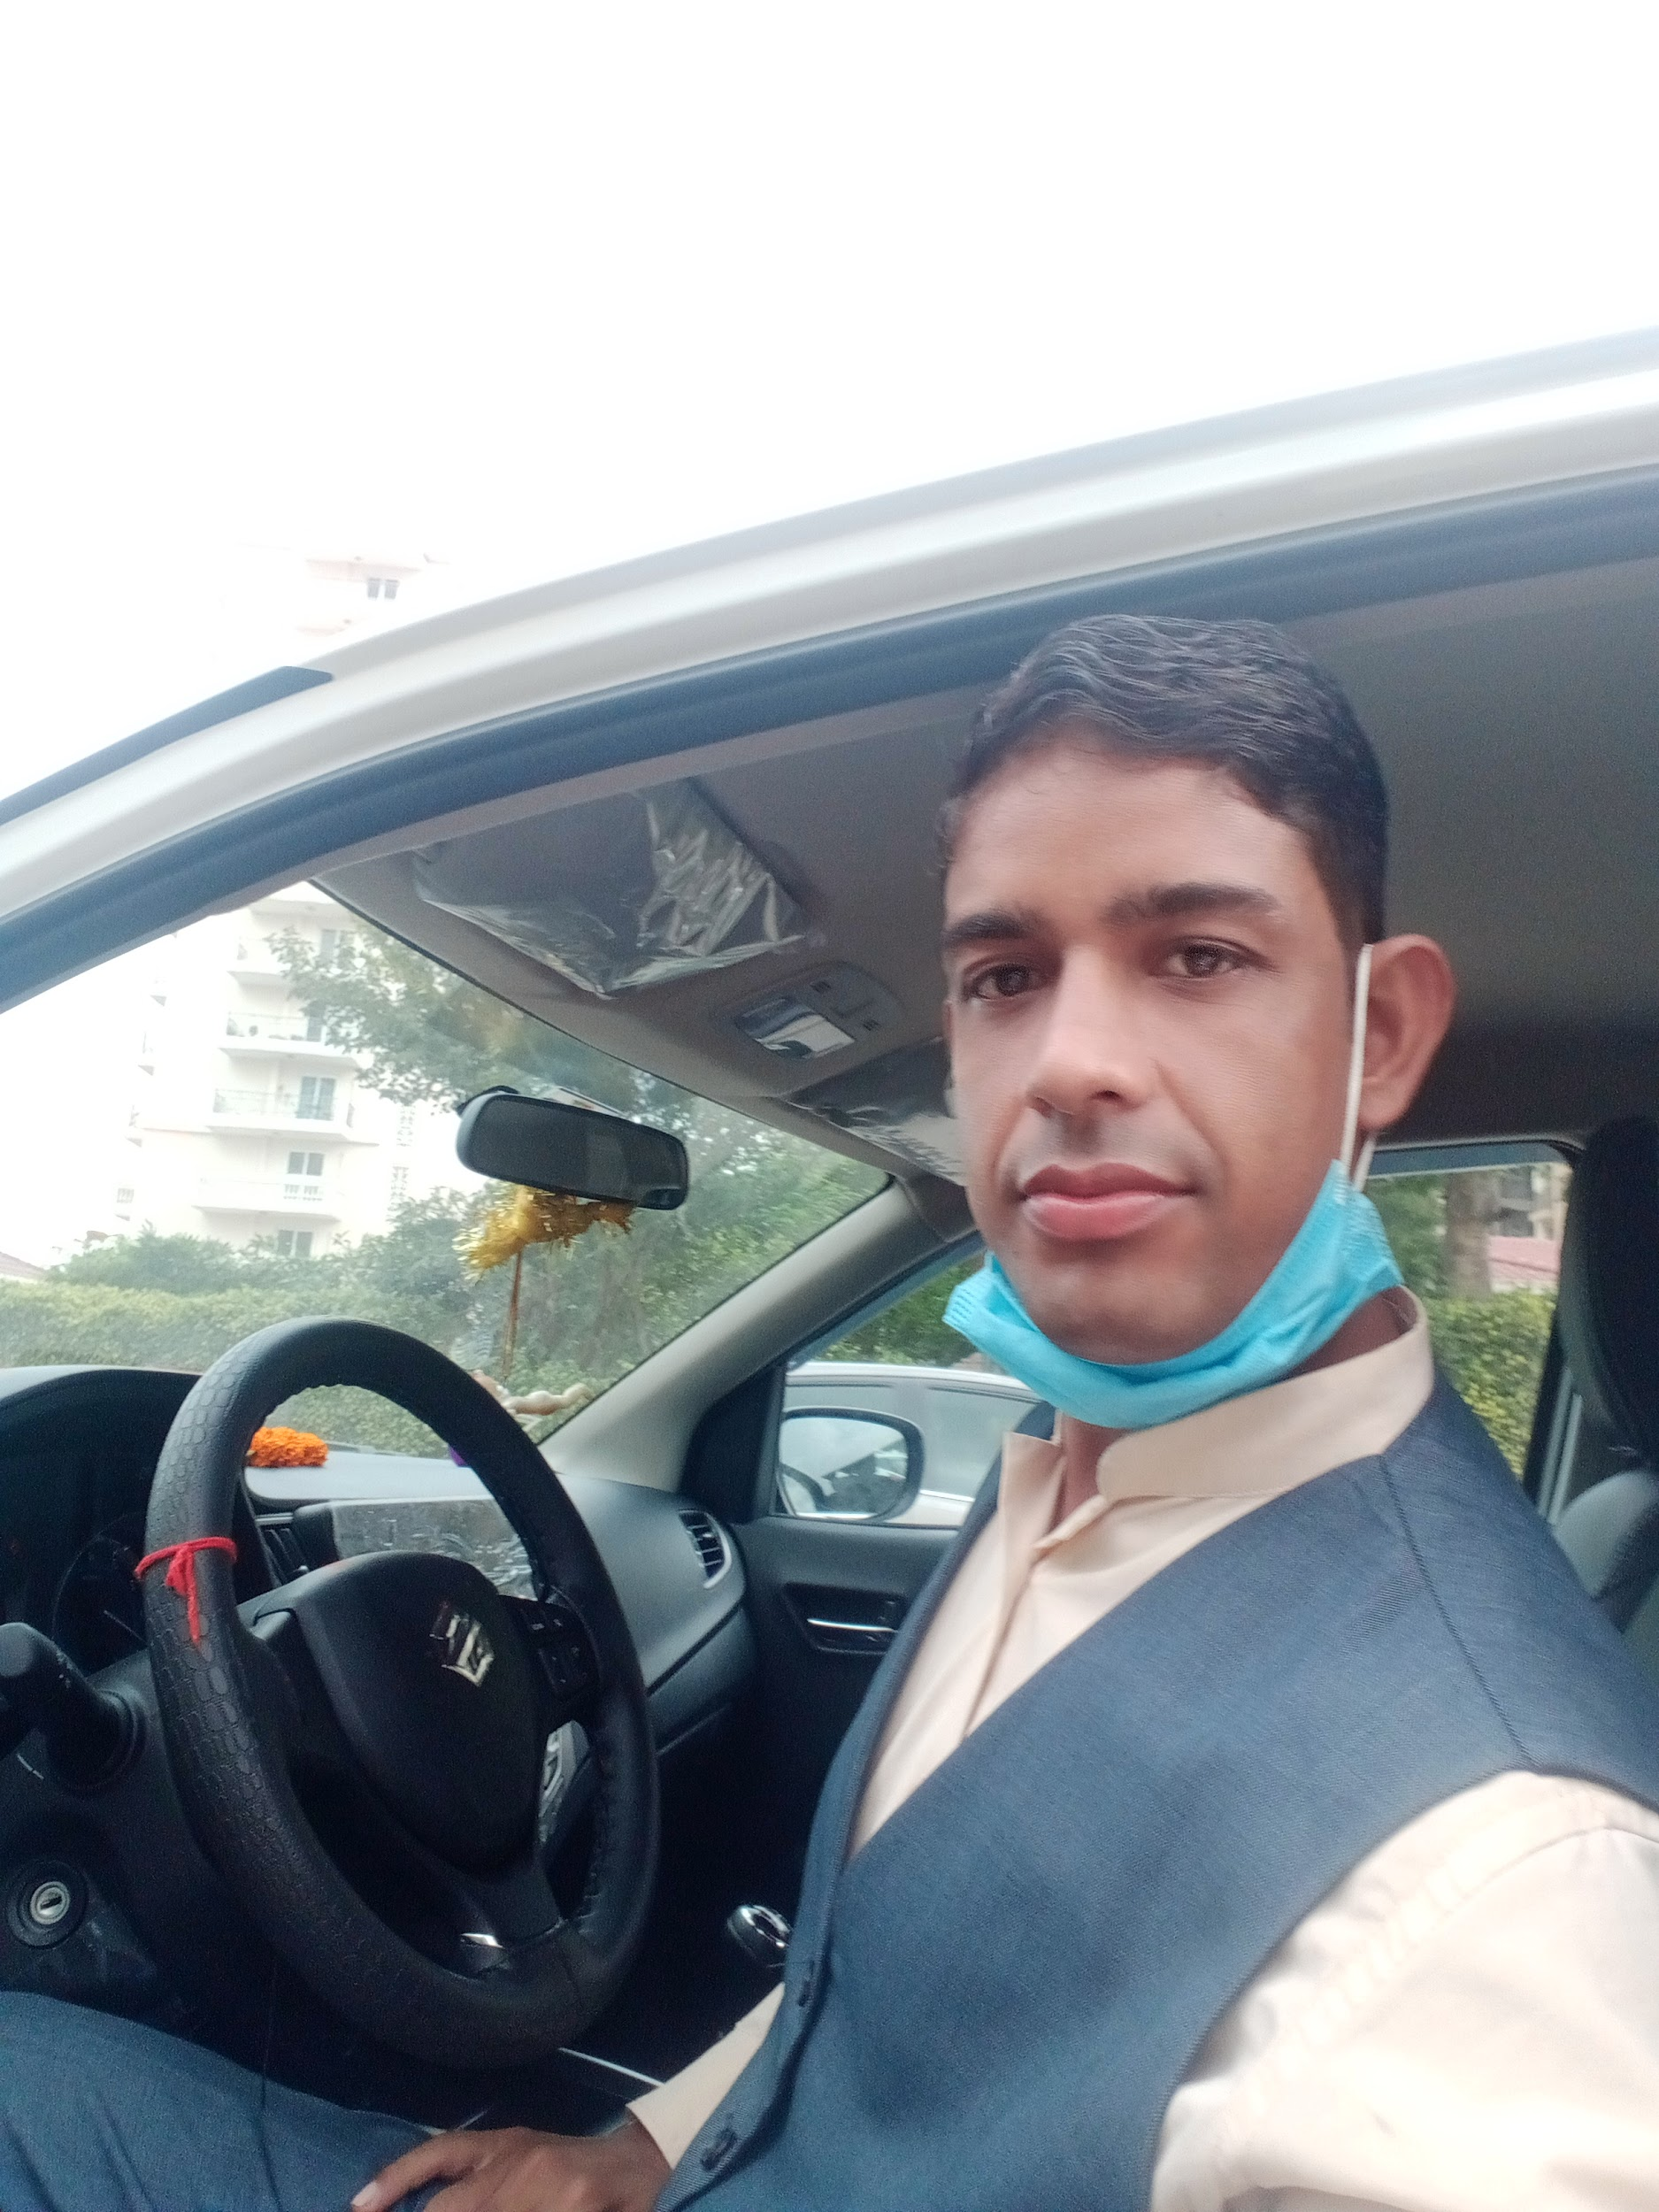

Area of Interest
- Food & Beverage service.
Hobbies
- Playing Cricket.
- Listening Music.
Strength
- Hard Working.
- Eager to Learn.
Personal Detail
- Father’s Name : Sh. Amar Singh Sharma
- Date of Birth : 19/12/1993
- Marital Status : Married
- Nationality : Indian
- Language Known : English, Hindi,
- Sex : Male

- DECLARATION :
I hereby declare that above written particular are of the best of my knowledge and belief.

Place: - ……………….. Signature
Date: - ……………..... (Gourav Sharma)

