• Contact  • Skills  Madellia.    Very Good  Salesforce    Good  Transcendent  Very Good  MESH  Good  Technical Analysis  Very Good  Detail drawings  Good  Problem solving ability  Very Good  Equipment installation  Good  Safety awareness  Very Good  Hand and power tools    Excellent  Blueprint and schematic understanding  Good |  | Skilled Maintenance Technician adept at interpreting blueprints, developing schedules and overseeing team operations. Well-versed in managing workflow and delegating tasks to meet objectives. Offering 2+ years of repair and maintenance expertise with proven history or hard work and dependability.  • Work History  • Education  • Personal Information  Father's Name : Mr. Kandhe Ram  Gender : Male.  Languages known : Hindi, English  Marital Status : Single.  Date of Birth : 09/03/ 2000.  Relocation : Willing to relocate.  Passport Number : V0332179  • Declaration  Here by, I declare that the above stated information is true to the best of my knowledge.  Place : Ludhiana  Date:  Yours Faithfully,  (GAURAV KUMAR)
   | Ludhiana Punjab
   | +91 84455 29965
   | Gauravkmr.090300@gmail.com
   | 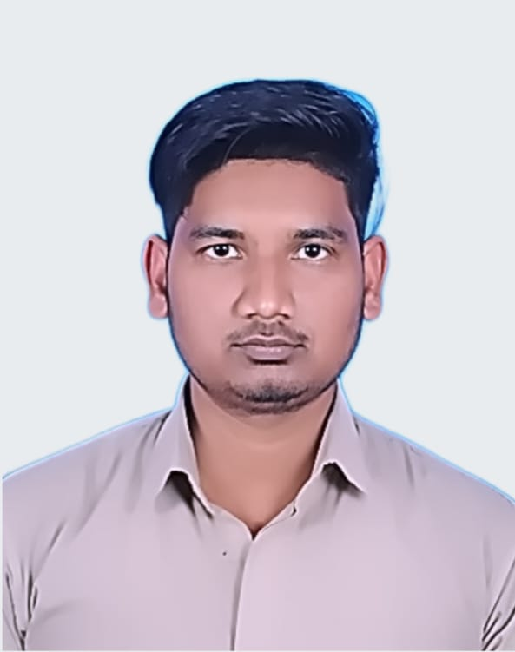 | GAURAV KUMAR  Engineering Associate
   | 2020-2021 |  | Assistant Electrician  MOTHERSON SUMI LTD LUCKNOW INDIA  - Reporting to Engineering Executive  - Assisting in the implementation of energy conservation program recommending maintenance system improvements and energy savings  - Responsible for engineering guest floor maintenance work  - Responds to guest request promptly in a professional and courteous manner  - Effective and smooth operation of the shift  - Maintains all equipment's in working conditions
   | 2021-2023 |  | Assistant Electician  TATA MOTOR PANTNAGAR UTTARAKHAND  - Respond immediately to all work request which concern Life and safety  - Working as a guest floor maintenance in charge in order to maintain of defectivemaintenance work  - Responds to guest request promptly in a professional and courteous manner  - Ensures the optimum performance of all Electrical panels and equipment's by effectively following the Preventive maintenance and the shift readings programs  - Maintaining all tools, equipment and working areas in good condition  - Effective and smooth operation of the shift  - Maintains all equipment's in working conditions  - Professional Ability  - Alarm Management System  - Maintenance of Electrical works 11kV HT and LT  - Maintenance & supervision of cooling system.
   | 2023 - Now |  | Engineering Associate  GTB ENGINEERS LUDHIANA PUNJAB  - HT/LT AC and electric motors  - Transformers testing  - HT/LT Switchgear Service and Testing  (ACB ,VCB,OCB SF6)  - Prepared standard reports and documentation to communicate resul  - ts to senior management.  - Attended maintenance related complaints to improve trouble shooting knowledge.  - Followed daily tasks which was given be senior associates and executives.  l.
   | 2017-2019 |  | Modern iti Chhatarpur Uttarakhand  NCVT ITI - India
   | 2017-2015 - |  | RIC Bhadeora Jaunpur  12th - India
.

