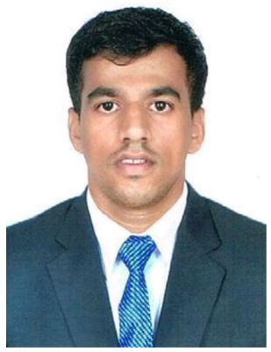
RESUME

SHRIKANT GAWAS
Present Address:-
Vill: Mangeli, Talewadi,
Po: Dodamaeg, Maharashtra,
Mobile No: 7020511776
Email Id: shrikantgawas2993@gmail.com

CAREER OBJECTIVE

Achieve a good opening in a reputed organization where I will have the opportunity to enhance my skill and strength in conjunction with my hotel industry goal on objective. I have qualities to bring to the work place such as a good team player, organization skill, Leadership skill and efficiency in all that I do. I work well under pressure and love to do work.

ACADEMIC QUALIFICATION

- S.S.C. Passed from Madhyamik Vidhyalay Sonaval School, Kokan Board 2010.
- H.S.S.C Passed in New English, Bhedshi 2012.

PROFESSIONAL QUALIFICATION

- Food & Baverage Prodution, Gesto Academy Porvorim - Goa. 2015-16
- Food & Baverage Service, Gesto Academy Porvorim-Goa. 2015-16

HOBBIES

- Cricket
- Cooking

STRENGTH

- Smart Work & Honest.
- Good Communication Skills.

AREA OF INTEREST

- Food & Beverage Production.
- Continental Department.

RESPONSIBILITIES

- Work according to the menu specifications.
- Keep work area at all time in hygienic according to the rules set by the hotel.
- Control food stock and food cost in his section.
- Maintain high standards of personal hygienic, grooming and presentation.
- Make sure that all the food items are received, checked and stored correctly.
- Always maintain high standard of food hygienic, cleanliness and tidiness in the kitchen storage fridge and freezers.

ACHIEVEMENTS

- Certification of Training
Goa Marriott Resort & Spa in Goa
(From 23rd September 2014 to 20th march 2015)

- Job Training
Citrus Hotels Calangute, Bardez Goa
15th September 2016 to 3rd December 2017

WORK EXPERIENCE

- Worked as Commi - III at Citrus Hotel, Calangute Goa from 2nd February 2016 to 14th September 2016.
- Worked as Commi III at Neo Majestic, Porvorim Goa from 18th November to 30th September 2021.
- Worked as Commi II for Hotel Fidalgo, Panaji Goafrom 11th November 2022 to 11th November 2023.
- Presently working as a Commi I Deltin Squid Nerul Condolim Goa from 21 December 2023 to till date.

PERSONAL INFORMATION

- Name: Shrikant Vasant Gawas
- D.O.B: 10th December 1994
- Gender: Male
- Father's Name : Mr. Vasant Gawas
- Marital Status: Married
- Nationality: Indian

I have confirmed that the above information given by me is true as per my knowledge and belief.

Date:
Place:

(Shrikant Gawas)

