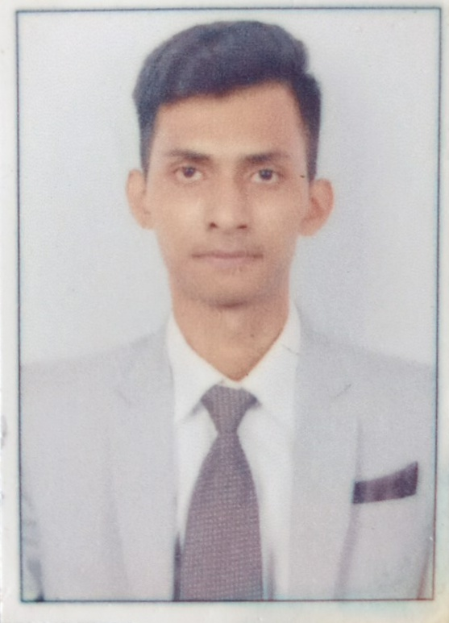
LAKHAN KATKAR

Contact : 9870602245 Email: lakhankatkar56@gmail.com

Vision & Career objective:

To excel in the company and be a catalyst in growth of an organisation. Looking to gain industry knowledge and experience in operations.

Professional Skills

- Quick and motivated learner.
- Understanding the job profile and putting in the maximum Efforts to meet deadlines and schedules with professional efficiency,
- Confident enough to take new and challenging opportunities.
- An effective communicator with excellent relationship building and interpersonal skill, problem solving & organisational abilities.

WORK EXPERIENCE:-

Bring iton! Restrobar owned by bringiton hospitality (1st Sep 2017 to 10th Mar 2018 )
Designation : Food and beverage server

- Maintain a professional and friendly demeanor and offer timely assistance to customers in order to ensure that their needs are met.

- Explain menu items, assist patrons with special dietary needs and recommend menu items that the restaurant would like to sell more of.

- Responsible for bringing orders from the kitchen to customers..

- Responsible to ensure that patrons receive their bills in a timely manner and that all orders are properly listed and priced. Process payments, operating the register and return paid checks and receipt to customer. Also, responsible for resolving any discrepancies in billing.

The Joker Bistro by cibusars hospitality LLP (1ST JUNE 2018 till date )
Designation : Food and beverage captain

- Greet and escort guests/customers to their allocated tables
- Assist in managing/handling guest restaurant reservations
- Good knowledge of menu (food and beverage) and presentation standards; offer menu recommendations upon request and aptly suggest additional options
- Serve guest orders as per restaurant standards Communicate order details to the kitchen staff, in particular VIP, special instructions etc.
- Ensure that the whole restaurant is always kept clean, organized and presentable at all times
- Complete closing duties, including restocking items, closing reports, etc.
- Routine inspection of all outlet equipment to assure all are in proper working condition and prepare a list of equipment in need of repair and maintenance
- Take an active role in coaching and developing junior staff
- Motivate staff through fair leadership.

Industrial Training :

Completed 5 Months Industrial internship at ITC Maratha hotel Mumbai, in all major departments .
- Food production, Front office, Food and Beverage, Housekeeping

Skills Acquired:

- Ensuring guests are looked after well and have an enjoyable and a comfortable experience.
- Ensuring restaurant standards are followed always. Indulging in bar activities and holding
sections and gaining good knowledge about food and majoring in food and beverage.
- Regular trainings of food and beverage and product knowledge.

Academic Achievements:

Academic milestones | Year of Passing | School/College | Board/University | Percentage/Grade
T.Y.BSC  (Hotel Management) | 2016-17 | Bharti Vidyapith | Mumbai University | B Grade
H.S.C (Science) | 2013-14 | Guru nanak khalsa collage | Maharashtra State Board | 51.69 %
S.S.C | 2011-12 | L.K. high school | Mumbai State Board | 81.45%

Strengths

- Hard working and punctual.
- Disciplined and well organized.
- Confident in handling high-pressure

Hobbies:

- Riding bike , swimming

PERSONAL INFORMATION:-

NAME - Lakhan Dasharath Katkar
D.O.B. - 7th October 1996
Address - 62/6 Parab niwas ,Hill Road ,Sion –Chunabhatti Mumbai - 400022
Nationality - Indian
Languages known - English , hindi , Marathi .
Pass Port No - T7654116
Date Of Issue - 06/08/2019
Date Of Expiry - 05/08/2029

I hereby declare that all the statements and information given by me is true and valid to the best of my knowledge and belief .

Date:
Place:

LAKHAN KATKAR

