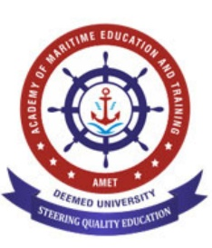
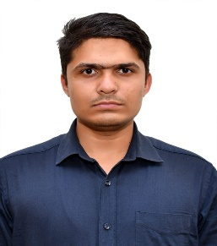
Name : FAHIM RAZA
Mobile No : 9123415644
Email: fahimrazasiddique@gmail.com
fahimsiddique123@gmail.com

Career Objective
Seeking a challenging role as a Marine Engineer with an established company in order to utilize my skills and knowledge for mutual benefit.
Education
- Pre sea course
  - Course : Graduate Marine Engineering
  - University : Amet University, Chennai
  - Year Of Passing : Pursuing

- Under Graduate

  - Course : Bachelor Of Technology (Mechanical Engineering)
  - University : Maharaja Ranjit Singh Technical University, Bathinda
  - College : Baba Farid College of Engg &Technology, Bathinda
  - Year Of Passing :2023
  - Percentage : 74%

- Higher Secondary

  - School : Gandhi Inter College, Gopalganj
  - Board : Bihar Board
  - Year of Passing : 2019
  - Percentage : 63%
  - PCM : 65%

- Senior Secondary

  - School : SS Public School, Gopalganj
  - Board : CBSE Board
Year of Passing : 2017
  - Percentage/CGPA : 8.8CGPA

TRAINING

- Pneumatic System : Fasto India Collab with BFCET, Bathinda
- Duration : July 2022 – Sep 2022
- SolidWorks : Infowiz Bathinda
- Duration : July 2021 – Sep 2021

PATENT : Refrigeration Tray Adjustment System
Application No : 202211033867
Date of Filing :14-06-2022
Date of Grant : 25-01-2024
Skills
- I’m patient with tasks, always to double check and verify
- Adoptable and resilient
- Good at management (Served as Club Secretary for 2 years)
Project Work
Sand Filter and Casting Mixture
EV with gear to enhance the performance or torque
Thermo-electric solar powered refrigeration
- Designed and developed to use for college purpose &save energy
Certification
- AutoCAD Certificate
- SolidWorks
- Certificate Of Appreciation from Punjab govt
- Fasto India
Hobbies
- Cooking
- Writing Urdu Poetry
- Trekking
Personal Information
Name : Fahim Raza
Date of Birth :30-12-2000
Passport Number : Z7088234
Indos Number : 24EM0310
CDC Number : MUM562049
SID NO. : C34885486
YELLOW FEVER : YFVC/042/PHO/2024/
Birth Place : Lohzira Manjhagarh
State of Origin : Bihar
Languages Known : Hindi, English, Urdu, Bhojpuri, Punjabi

