





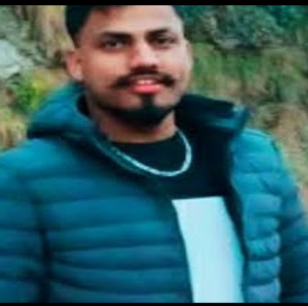AMIT
KUMAR

OBJECTIVE
- Aspire to associate myself with a professionally run business organization, that has potential for growth - both organizational and personal and provide ample opportunity to learn, improve and implement.

Vill. Gorat

P.O Kakroti The-Bhattiyat Distt Chamba Himachal Pradesh
Pin No-176207




8080651247



kaushalamit0059@gmail.com
INDIVIDUAL TRAITS
- Continuous Improvement, Innovative &creative.
- Excellent Communication, analytical and problem solving skills. • Resource / people management
- Willing to travel & relocate.

Experience
- Jun 2017– May 2020
- Job Experience As a Waiter Hotel Hoenymoon Inn Manali (H.P)
- June 2020 – May 2023
- Job Experience As A Waiter Hotel And Restaurant in Goa

Responsibility

- Provide Excellent Customer Services





2. Always Strive Towards Best Coustmer Satisfaction

3. Greet Customers And present Menus

4. Make Suggestions Based On Their Preferences

5. Take And Serve Food/Drinks Orders.

6. Up – Sell When Appropriate

7. Arrange Table Settings

8. Keep Table Clean And Tidy At All Times

9. Check Products For Quality

10. Deliver Checks And Collect Payments

11. Cppperate And Communicate With All Serving And Kitchen Staff

12. Adhere To All Relevant Health Department Rules / Regulations And All Customer Service Guidelines.

Education.
- 12th From HPBSE Dharamshala

- 10th From HPBSE Dharamshala

Hobbies

- Playing Cricket, Traveling, Listening Music.

Personal Information

Father’sName:

Date of Birth : Marital Status : Nationality :
Sh Bihari Lal 28/06/1998 unmarried Indian

Signature

