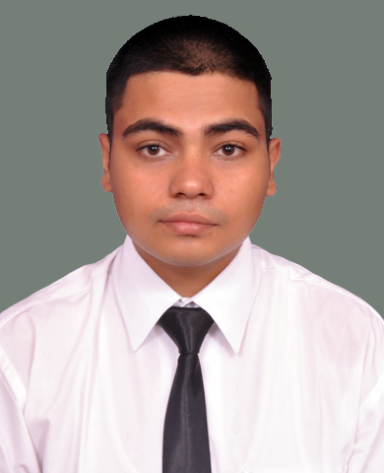  HIMANSHU SACHDEVA  PERMANENT Address/PRESENT ADDRESS:  D-36, Subhash Nagar, Mahipal Colony, Roorkee -247667  MOB +919756443535  E-mail:  himanshusachdeva02@gmail.com  STRENGTH :  - Punctuality  - Hard Working  - Creative  - Quick Learner  Languages Known:  English, Hindi , Punjabi  HOBBIES:  Travelling  Surfing Internet  Listening Music | OBJECTIVE:  To attain a respected position in the organization where my education and acquired skills will be utilized toward continued growth and advancement so that people can acknowledge and appreciate my work.  PERSONAL DETAILS :  Name: Himanshu Sachdeva  Date of Birth: 03-Jul-1994  Sex: Male  Nationality: Indian  Marital Status: Unmarried  Fathers Name: Mr. Ashwani Sachdeva  Mothers Name: Mrs. Veena Sachdeva  ACADEMIC QUALIFICATION :  - Passed 10th from NIOS in 2010  - Passed 12th from NIOS in 2012  - Pursuing B.com (2nd year) from Garhwal University.  - Completed Diploma in Food Production from IHM Dehradun in 2014-2015.  TRAINING:  Successful completion of Industrial training:  - 02 Months at Radisson Blu, Noida(June 2015-Aug 2015)  - 04 Months at The Lalit, Chandigarh (Sep 2015-Jan 2016)  ACHIEVEMENTS:  - Won the 1st prize for making best seekh kebab at college level  - Active participation in Bharat swach abhiyaan organized by college  - Worked in various food stalls organized by college  - Member of the production team for Hnble CM Harish Rawat  - Assisted Range Chef in preparation of 300 pax dinner during a conference at The Lalit Chandigarh  - Worked in various festival like Diwali, Christmas, New Year and Lohri which gave opportunity to prepare best menus  Job Skills:  - Menu Planner  - Kitchen Supervisor  - Food Cost Controller  - Create New Recipes  - Cuisine Knowledge – Indian , Indo-Chinese, Italian, Spanish, Russian, Basic Bakery,  EXPERIENCE:  - CDP at Calibers, Al Bateen palace, Abu Dhabi ,19 October to till December 2023  - CDP at Krave Restaurant, ITALIAN AND MEXICAN. DUBAI May 2023 to October 2023  - DCDP at Etihad Airways Flight Catering, Abu Dhabi, UAE, October 2021 – March 2023  - DCDP at Devyani International Ltd IGI Airport Delhi : July'19 – April’2021  - Outlet Incharge at Inner chef pvt ltd, Italian OutLet Delhi : Jan 2019 to July 2019  - Commie at Ramada Chelsea Hotel, Dubai(UAE) : Dec2017 till Dec'2018  - Management Trainee at Lemon Tree Premier, Leisure valley, Gurgaon Date 15 nov 2016 till December17.  - Six months with Café OMG, Connaught Place, New Delhi.  COMPUTER PROFICIENCY:  Good working knowledge of:  - MS Office  - Internet
DECLARATION:
I do hereby declare that the above-mentioned details are true to the best of my knowledge and belief. If anything found wrong, my candidature is liable to be cancelled.
Date: HIMANSHU SACHDEVA

